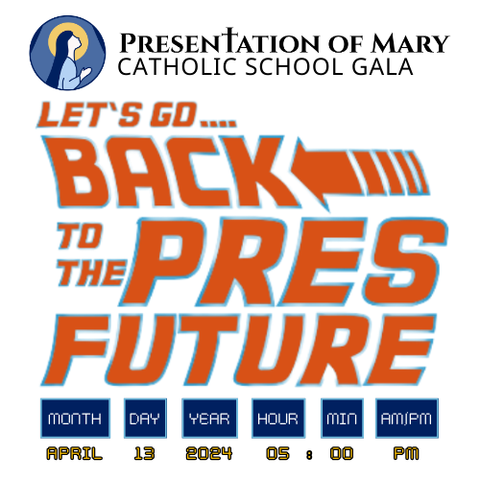
2024 Gala
Raffle Ticket Information Sheet

1 Raffle Ticket: 3 great prizes!!

This year, the Gala Committee is selling 1 raffle ticket for $10. Each raffle ticket is an entry to win one of 3 prizes. The Raffle Prizes will be drawn on April 13, 2024 during the Gala.

Raffle sales should be complete, and all tickets and money should be submitted to the school office by the morning of Friday, April 12.

First Prize:
- $1,500 Cash donated anonymously
Second prize:
- Fill your freezer with a quarter of a cow: Black Angus Grass Fed beef donated by Sandberg Land and Cattle Company
  - Beef can be delivered within the Twin Cities Metro Area
  - $1,000 value
  - Sandberg will arrange processing and delivery with the winner!
Third Prize:
- $500 Sponsored by the Gala Committee.
  - Save it for a rainy day
  - Apply it to next year’s tuition
  - Use it in the Gala to buy something you really want!

Students have some fun incentives for selling:
- For every 10 tickets they sell, they will get an out of uniform pass
- The first 20 students to sell 20 tickets will earn a coupon for a free ice cream cone at McDonald's
- The class that sells the most tickets will win a McDonald's French Fry and Movie party
- The top selling student will win a Chromebook
- The 2nd place selling student will win high-tech headphones
- The 3rd place selling student will win a drone

And... if the school as a whole sells at least 10 tickets per student (for a total of 1,410 tickets), we will get an extra day off of school!!! (Date TBD)

